**Project Title**

**Job Portal for Job Seekers and Recruiters**

**CA-2( Cse326 )**

**Section K23CT**

***Group members:-***

***1.Ansh Raturi(55)***

***2. Akshat Kumar (59)***

***3.Karteek Pal Hirnwal (80)***

**Description**

**We have created an interactive job Portal where user can find job or recruit as per thier need and also a added about us because if they wants to know who designed this website or wants to follow us they can and contact us to make them feel supported as user will be able to reach out to us if they are stuck somewhere.**

**Some of the html tags used**

<Title>, <Nav>,

<Div>,<Input>,<form>,<section>,<button>,<section>

**Some of the Css tags used**

Margin,Padding, colour,

Background, Position, Align Item ,

font-size, font-width,

Text-decoration, Border-radius

**Code snippets**

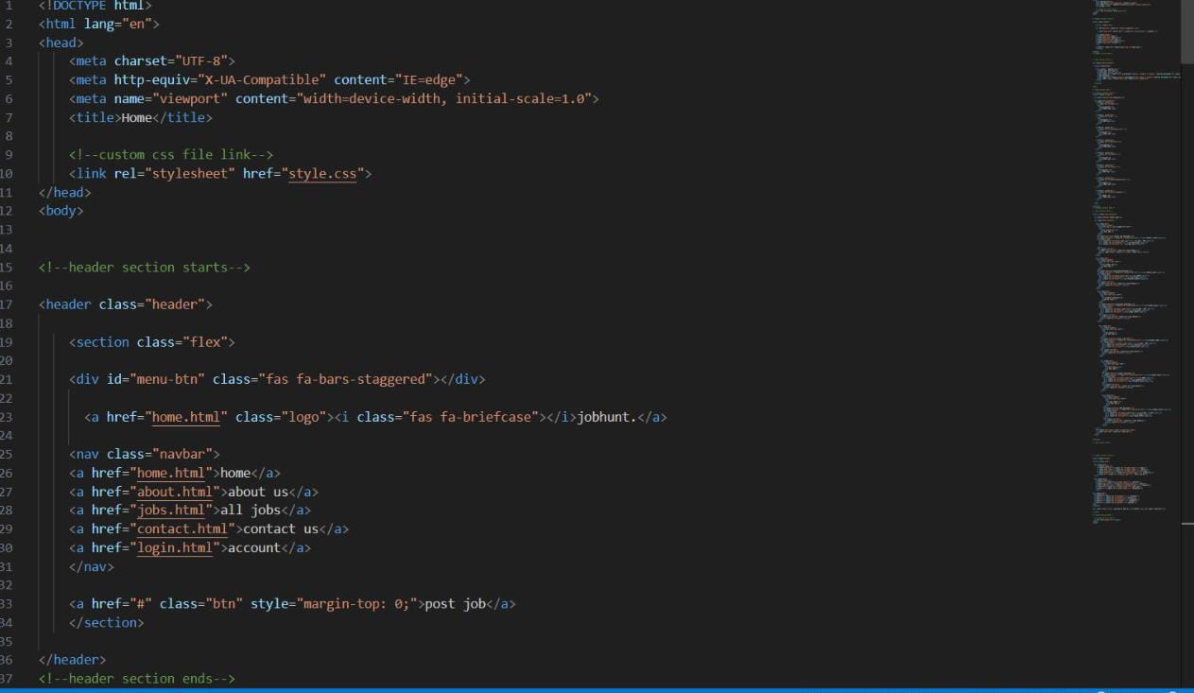

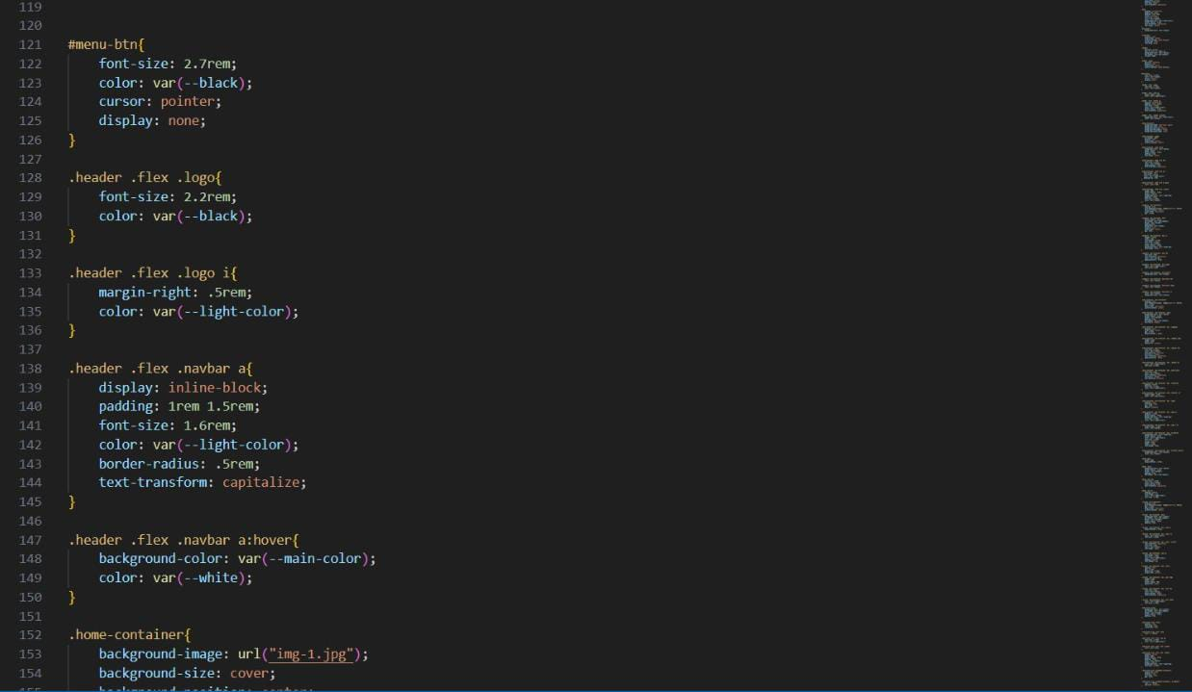

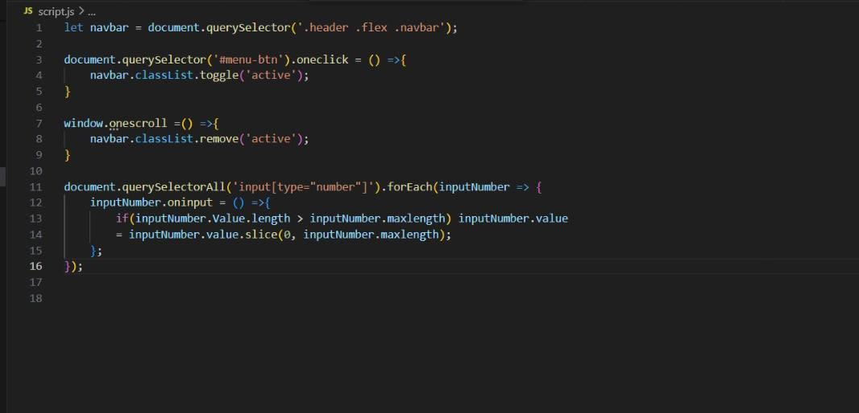

**Website screenshots**

